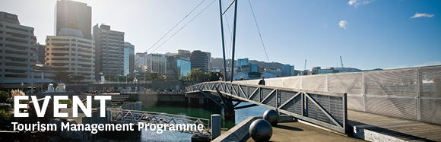

|  |  |  |  |  |  |  |  |  |  |  |
| --- | --- | --- | --- | --- | --- | --- | --- | --- | --- | --- |
| |  |  |  |  |  |  |  |  |  |  | | --- | --- | --- | --- | --- | --- | --- | --- | --- | --- | | |  | | --- | | The Tourism Management Group, part of the School of Management, Victoria Business School,  invites you to attend the following seminar: | |  | | **Are They Serious?  An Arts-Informed Life History Approach to Study Event Travel Careers of Singaporean Artists and Producers** | | | Presenter: **Sandra Goh**  PhD candidate, Tourism Management, Victoria University of Wellington  **Wednesday 12th April**  **12.30 – 1.30pm**  **Boardroom, Level 12, Rutherford House**  **Pipitea Campus, Wellington**  This seminar examines how amateur and professional artists and producers develop their event travel careers in Singapore, and the factors that constrain or facilitate it, using an arts-informed life history approach. An integrative framework of serious event travellers was conceptualized, revealing the presence of local, regional, dispersed, and social world systems as the catalysts in developing their event travel careers. The researcher welcomes all supporters and critiques of research frameworks and qualitative studies to this seminar.  **Presenter**  Sandra is a practicing academic and event fanatic and has recently submitted her thesis for examination. She was a lecturer with Temasek Polytechnic in Singapore and an event practitioner.  ALL WELCOME | | |  | | |  |   Any queries please Email: [tourism@vuw.ac.nz](mailto:tourism@vuw.ac.nz) |
|  |