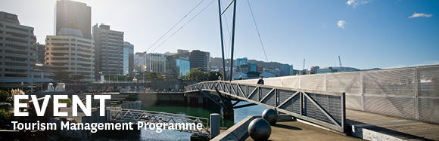

|  |  |  |  |  |  |  |  |  |  |  |
| --- | --- | --- | --- | --- | --- | --- | --- | --- | --- | --- |
| |  |  |  |  |  |  |  |  |  |  | | --- | --- | --- | --- | --- | --- | --- | --- | --- | --- | | |  | | --- | | The Tourism Management Group, part of the School of Management, Victoria Business School,  invites you to attend the following seminar: | |  | | Evaluating the Effects of Climate Change on Tourism: Methods and Findings | | | Presenter: **Jaume Rossello-Nadal** Associate Professor at the Department of Applied Economics at the  University of the Balearic Islands (Spain).  **Monday 5th September**  **12.30 – 1.30pm**  **Room 1113, Level 11, Rutherford House**  **Pipitea Campus, Wellington**  During last years, different empirical studies have conducted evaluations of the effect of climate change on tourism based on different methodologies and perspectives. The aim of this presentation is to assess the most popular quantitative methods used in the literature. This review aims to shows how the effects of climate change can first be assessed through changes in physical conditions essential to tourism (like snow cover); secondly, by using climate indexes to measure the attractiveness of tourist destinations; and, thirdly, by modelling tourism demand with the inclusion of climate determinants. Results suggest that although some methodologies are in the early stages of development, different approaches result in a similar map of those areas mainly affected by the global warming problem.  **About the presenter**:  Jaume Rossello-Nadal is Associate Professor at the Department of Applied Economics at the University of the Balearic Islands (Spain). He gets his PhD in Economics and Business at the same University in 2001 on tourism demand modelling and forecasting. He teaches microeconomics, tourism demand modelling and tourism economics at graduate and master levels. He has published over 25 research papers in international journals and books, monographs and collective volumes. He is currently Vice-dean of Economics in the Faculty of Business and Economics and he is currently involved in different research projects related to climate change and tourism. In 2009 he was awarded 'Emerging Scholarship' from the International Academy for the Study of Tourism. See more information at: <http://www.uib.es/depart/deaweb/webpersonal/jaumerossello/en/>  ALL WELCOME | | |  | | |  |   Any queries please Email: [tourism@vuw.ac.nz](mailto:tourism@vuw.ac.nz) |
|  |