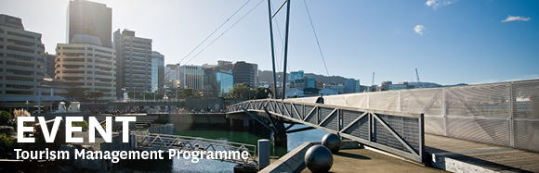

|  |  |  |  |  |  |  |  |  |  |  |
| --- | --- | --- | --- | --- | --- | --- | --- | --- | --- | --- |
| |  |  |  |  |  |  |  |  |  |  | | --- | --- | --- | --- | --- | --- | --- | --- | --- | --- | | |  | | --- | | The Tourism Management Group, part of the School of Management, Victoria Business School,  invites you to attend the following seminar: | |  | | The power of process management in  New Product Development (NPD)  – results from state-of-the-art literature and selected empirical studies in tourism: Implication for practice and future research | | | Presenter: **Kåre Sandvik**  (Ph.D., Norwegian School of Economics and Business Administration, 1998),  Professor of Marketing, School of Business, University College of Southeast Norway  **Wednesday 23rd March**  **12.30 – 1.30pm**  **Boardroom, Level 12, Rutherford House**  **Pipitea Campus, Wellington**  Most companies attempt to use innovativeness as one of their strategic tools to succeed in markets. Many studies demonstrate how much NPD varies and how common and new success factors may explain why some companies succeed better than other does. The presentation gives a blend of state-of-the art research on market-oriented NPD success and include the results and “behind the scene” issues of Sandvik’s research during the last 20 years. His research has been with hotels and other travel sector industries. The presentation concludes with suggestions for implications for practice and future research.  **About the presenter**:  Sandvik has published in numerous journals, including the International Journal of Research in Marketing, Journal of Service Research, Journal of Tourism Futures, Journal of Travel Research, Cornell Hospitality Quarterly, Tourism Economics, International Journal of Advertising, Journal of Supply and Purchasing Management, and more. He won best overall paper awards at European Marketing Academy 1995, Norwegian Conference in Business Administration 1998, and 2003 Winter AMA. He is currently the director of a new large grant research project, entitled “Developing Sources of Competitive Advantage in the Norwegian Travel Industry”, a unique business performance research project that includes all of the largest companies and more than 60% of the sales in the industry. Sandvik has an extensive record of strategy and marketing consulting with leading Northern European companies, many of them within the travel sector.  ALL WELCOME | | |  | | |  |   Any queries please Email: [tourism@vuw.ac.nz](mailto:tourism@vuw.ac.nz) |