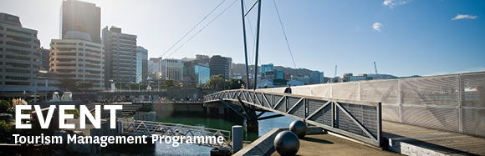

|  |  |  |  |  |  |  |  |  |  |  |
| --- | --- | --- | --- | --- | --- | --- | --- | --- | --- | --- |
| |  |  |  |  |  |  |  |  |  |  | | --- | --- | --- | --- | --- | --- | --- | --- | --- | --- | | |  | | --- | | The Tourism Management Group, part of the School of Management, Victoria Business School, invites you to attend the following seminar: | |  | | Destination Management in Chile | | | **Presenter: Doug Pearce**  Emeritus Professor, Victoria University of Wellington  **Thursday 14th April**  **1.00 – 2.00pm**  **Boardroom, Level 12, Rutherford House**  **Pipitea Campus, Wellington**  This seminar examines the relationships between the multiple objectives, actions and actors involved in destination management in Chile based on the analysis of tourism and territorial plans for the regions of Valparaíso, Los Ríos and Aysén. The current approach emphasizes supply-side development by many actors and multiple actions. A model representing the Chilean approach to destination management will be presented and its implications discussed.  **About the presenter**:  After retiring as Professor of Tourism Management at Victoria in January 2015, Doug spent six months in Chile as a Visiting Professor in the Instituto de Turismo at the Universidad Austral de Chile in Valdivia. His visit was funded by CONICYT.  **ALL WELCOME** | | |  | | |  |   Any queries please Email: [tourism@vuw.ac.nz](mailto:tourism@vuw.ac.nz) |
|  |