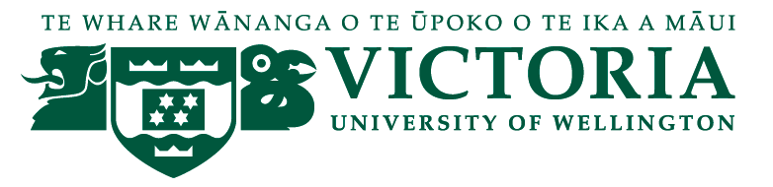

School of Management – Tourism Management Group

TOURISM MANAGEMENT SEMINAR

We are pleased to present the following seminar in our 2015 series:

Amparo Cervera
University of Valencia
Spain

Research and managerial opportunities in the Mediterranean Sea from a stakeholders’ perspective

Wednesday 27th May, 12:30 - 13:30
followed by refreshments

Level 12, Boardroom, Rutherford House, 23 Lambton Quay

This seminar is based on the findings of a Cross-Border Cooperation Project in the Mediterranean sea to promote sustainable development of tourism destinations in countries, such as Spain, Italy, Lebanon, Tunisia and Jordania. Amparo will be also discussing about opportunities for international networks and research cooperation in the Mediterranean sea.

Amparo Cervera is a researcher at the Institute of International Economy (University of Valencia). She has published more than 50 journal articles and book chapters. Her areas of interest are related to Tourism and Services Marketing; Public and Nonprofit Marketing; Strategic Marketing - resources and capabilities for innovation, Experiental and International Marketing.

Amparo is currently the Vice President of the International Association on Public and Nonprofit Marketing.

Any queries please contact tourism@vuw.ac.nz

