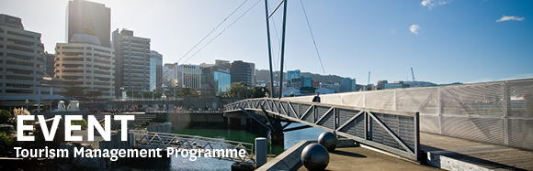

|  |  |  |  |  |  |  |  |  |  |  |  |
| --- | --- | --- | --- | --- | --- | --- | --- | --- | --- | --- | --- |
| |  |  |  |  |  |  |  |  |  |  |  | | --- | --- | --- | --- | --- | --- | --- | --- | --- | --- | --- | | |  | | --- | | The Tourism Management Group, part of the School of Management, Victoria Business School, invites you to attend the following seminar: | |  | | **The evolution of New Zealand's tourism datasets** | | | | Presenters: Rebecca Burson, MBIE and Bernie Hanratty, StatsNZ  **Wednesday 12th August**  **12.30 - 1.30pm**  **RWW 501, Level 5, Railway West Wing**  **Pipitea Campus, Wellington**  Join Rebecca Burson from the Ministry of Business, Innovation and Employment and Bernie Hanratty from Statistics New Zealand as they outline key government tourism datasets and the current innovations and developments of these statistics, including advances in the use of electronic card transaction data to measure tourism expenditure.  Rebecca Burson is a Senior Research Analyst in the Sector Trends team at the Ministry of Business, Innovation and Employment. She has a PhD in Psychology and a Bachelor of Arts in Psychology and Sociology from Victoria University of Wellington. Since joining MBIE, Rebecca has been involved in a variety of tourism products, including the International Visitor Survey and the Regional Tourism Indicators and Estimates. Rebecca is currently leading a review of the Regional Tourism Indicators, due for completion later this year. Rebecca has also contributed to the 2015 Regional Economic Activity Report, due for publication in August/September this year.  Bernie Hanratty is a Statistical Analyst in the National Accounts Economics team at Statistics New Zealand. He has a Bachelor of Tourism and Services Management from Victoria University of Wellington. Bernie is responsible for the delivery of the Tourism Satellite Account, measuring tourism's contribution to the economy by way of expenditure and employment. Bernie was a key member of the Tourism 2025 growth framework project team and is also involved with the development and delivery of Regional Gross Domestic Product. | | |  | | |  |   Any queries please Email: [tourism@vuw.ac.nz](mailto:tourism@vuw.ac.nz) |
|  |