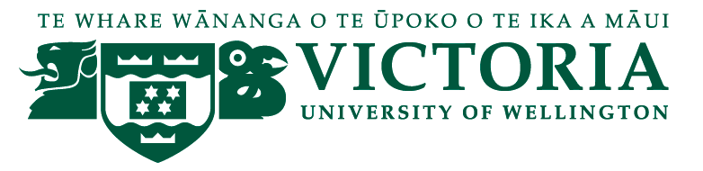

School of Management – Tourism Management Group

TOURISM MANAGEMENT SEMINAR

We are pleased to present the following seminar in our 2014 series:

Destination Management in New Zealand: concepts and practice
Professor Doug Pearce

Wednesday 22nd October 12:30 - 13:30
Boardroom, Level 12, Rutherford House,
23 Lambton Quay

This seminar addresses the question of how destination management is understood and practised in different parts of New Zealand. It is based on recent research which synthesizes the different meanings and concepts of destination management in the literature; analyses the ways in which destination management is defined and used in tourism strategies and plans and examines the different structures by which aspects of destination management are undertaken in a range of New Zealand destinations. Analysis of the strategies and discussions with RTO, council and industry representatives reveal a great deal of variation in terms of how destination management is conceptualized and carried out. Destination management is generally not seen as a high level, over-arching function but more as a series of discrete activities lacking much integrative structure. Two frameworks are offered as a means of sharpening the focus on destination management issues.
Doug Pearce is Professor of Tourism Management at Victoria University of Wellington.

Any queries please Email: tourism@vuw.ac.nz

