The Nation and Its Imagined Past
among the Levantine Diaspora, 1900-1936

David Hannah, Victoria University of Wellington

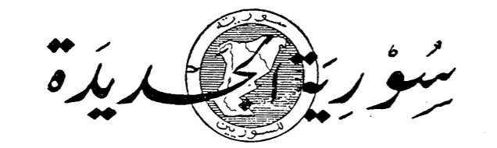

This talk will deal with the contingency and choice within “diaspora nationalism” as it manifested among Levantine communities overseas, in particular those in the United States, Brazil and Egypt. It will examine the three dominant nationalist positions pertaining to the Levant; Lebanism, Syrianism and pan-Arabism. In order to better understand these positions, the writings of prominent diaspora nationalists will be used to discuss the ideologies; Naoum and Salloum Mokarzel for the Lebanist position, Antoun Saadeh for the Syrianist position, and Jurji Zaydan and Ameen Rihani for the pan-Arabist position. The nationalists discussed here all imagined their respective homelands in two different senses; spatially and chronologically. In this talk I intend to both illustrate and compare how they imagined their homelands, and what said imagining means for the study of diaspora and nationalism.

David Hannah is completing a master’s degree in history at Victoria University of Wellington. His research mostly focuses on national movements in the 20th Century Levant.

The talk takes place on zoom: 98064489218
(or click this link: https://vuw.zoom.us/j/98064489218 )

Join us on 27 April 2022 at 5:00 pm

