Understanding ISIS/ISIL

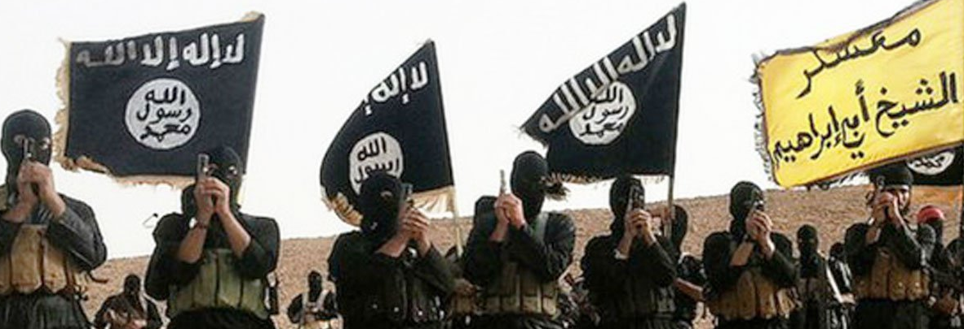

The emergence and success of the Islamic State of Iraq and the Levant, popularly known as ‘ISIS’ or ‘Daesh,’ has had tragic consequences for people living in Syria and Iraq, but also aroused consternation and alarm in Europe, America, and beyond. This interdisciplinary workshop attempts to look beyond popular hysteria to consider the significance of the Islamic State for the Middle East, for the Islamic world, for Russia, and/or for the Western powers.

The event occurs in the New Kirk Lecture Theatre (KKLT 301) on the Kelburn Campus of Victoria University. The event is free and open to the public

Abstracts

Hossein Aghapouri (Auckland University)
“ISIS and the Kurdish Question”

In the context of current massive changes as a result of ISIS/ISIL, the Kurdish question has brought back to the international arena. However, this time Kurds are not perceived as a trouble maker to the region, but the people who can deter Islamic fundamentalism and terrorism and embrace democracy, human rights and secularism. The current symbols, values and aspirations used by Kurdish nationalist actors during the ISIS crisis indicate a transformation in the Kurdish nationalism. By looking at the internal and external developments of Kurdistan in Iraq and Syria, this seminar/paper tries to explore whether these changes can be interpreted as the transformation of Kurdish nationalism from a purely Kurdish ethnic nationalism toward an ethno-civic model of Kurdistani identity in Kurdistan of Iraq and Kurdistan of Syria.

Alexander Maxwell (Victoria University)
“ISIS and the future of Arab Democracy”

The atrocities of the ISIS regime have caused some analysts to doubt the theoretical possibility of democratic government in the Arab world, or alternatively in the Islamic world. A long historical view of democratization, however, suggests that progress toward democratic government is steady. This paper contrasts ISIS propaganda with broader themes in recent Arab history, paying attention to its ideas of legitimacy. It suggests that the long-term prospects for Arab democracy are less gloomy than current events might suggest.

Abstracts

Hanlie Booysen (Victoria University)
“Are Islamists rational political actors?
Case study IS/ISIS”

IS has been labelled jihadi, salafi-jihadi, and takfiri in response to its extremist actions and a narrow interpretation of the Qur’an. While the influence of an ideology based on divine revelation cannot be discounted, such a single focus has skewed policies and analysis on how to deal with IS. In shifting the focus to IS’ political environment, I will argue that IS acted as a rational political actor in pursuing an Islamic state. In doing so, I will focus on IS’ utilisation of a) the political instability in Iraq and Syria; b) Sunni discontent in response to de-Ba‘thification in Iraq; and c) the Sunni-Shi‘a divide.

Conference schedule 11 March 2017

12:00 am 12:15
Welcome and introduction
Alexander Maxwell

12:15 – 12:45
“ISIS and the Kurdish Question”
Hossein Aghapouri (Auckland University)

12:45 – 1:15
“ISIS and the future of Arab Democracy”
Alexander Maxwell (Victoria University, Wellington)

1:30 pm – 2:00
“Are Islamists Rational Political Actors? Case study ISIS”
Hanlie Booysen (Victoria University, Wellington)

2:00 – 2:30
Roundtable discussion
All three panelists

Conference dinner

We will meet informally at 6:00 pm at the Marrakech Café
305 Evans Bay Parade, tel: 386-2884

