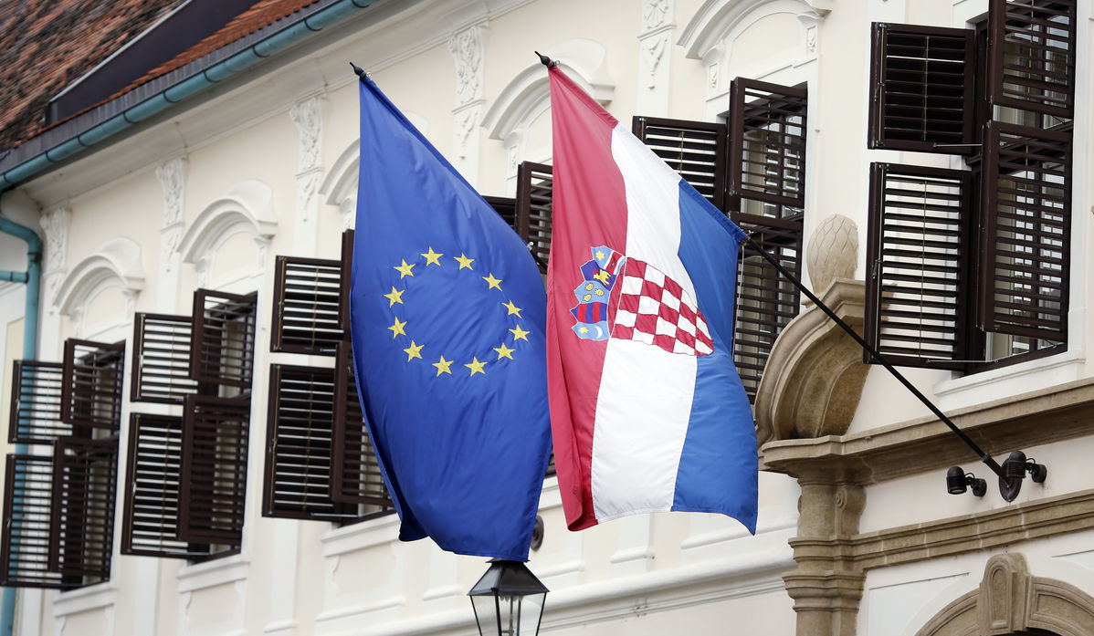
International Norms and East European Nations
Timothy Garton Ash notoriously claimed that the collapse of Communistm in East-Central Europe brought forth “no fundamentally new ideas on the big questions of politics, law, and international relations.” All too often, scholars examine the region’s post-Communist “transition” by asking whether countries have or have not accepted or implemented institutions or values originally developed in Western Europe or North America. Eastern European nations, however, have their own aspirations rooted in domestic history and traditions. The garments of progress and democracy must be tailor-made: one size does not fit all. While local elites may also pursue illiberal policies under the banner of local peculiarity, they may rightly detect imperial self-interest santimoniously posing as progress or “international norms.”
This workshop examines institutional, legal, ideological or cultural tensions between international actors and local elites. How do such tensions affect contemporary diplomacy in East Central Europe? How might they be resolved to mutual satisfaction?

5 February 2015 Victoria University, Wellington Wood Seminar Room (OK 406)
Participant Contact Information

Joe Burton joe.burton(at)vuw.ac.nz
Alexander M. Campbell alex_campbell46(at)hotmail.com
Fred LeBlanc fredleblancphd(at)gmail.com
Alexander Maxwell alexander.maxwell(at)vuw.ac.nz
Stuart Prior karakaby(at)yahoo.co.nz
Wenwen Shen wenwenshen7(at)gmail.com
Simona Soare simona.soare(at)dri.snspa.ro
Olga Suvorova suvorova2005(at)mail.ru
Conference Schedule

9:50 a.m. Welcoming Remarks
Alexander Maxwell and Wenwen Shen

10:00 – 11:00 “Diplomacy, Investment, and International Relations”
Stuart Prior (Honorary Consul for Belarus, Wellington)
“Integrating into the Global Market – Belarus, Russia, Ukraine”

Wenwen Shen (Victoria University)
“China, Eastern Europe, and Europe”

11:00 – 12:00 “The Evolution of Normative Stanards”
Alexander Maxwell (Victoria University)
“Abkhazia and the Donbass: A Tale of Two Interventions?”

Joe Burton (Victoria University, Politics)
“Estonia’s Role in the Diffusion of Cyber Security Norms”

12:00 – 1:00 Lunch Break

2:00 – 3:00 “The EU and Human Rights in Eastern Europe.”
Alexander M. Campbell (CEU, Budapest)
“Viktor Orbán: The Case of Hungary and the European Union.”

Fred LeBlanc (University of Otago)
“Why the Ukrainian Crisis is a Queer Issue”

3:00 – 4:00 “Responding to Crises”
Simona Soare (National University of Political and Administrative Studies)
“NATO Crisis Management Norm-sharing in Eastern Europe”

Olga Suvorova (Russian Keys Limited, Wellington)
“Post-Soviet Transdniestria – The Gilded Bust of Voltaire”

Conference Abstracts

Joe Burton (Victoria University, Politics)
“Estonia’s Role in the Diffusion of Cyber Security Norms”

Estonia was subjected to a barrage of cyber-attacks from Russian hackers in 2007 that shut down government ministries, media outlets and financial institutions. This paper examines the extent to which the attacks drove the adoption of cyber security norms within the EU and NATO. The paper argues that cyber security norms in the European area are at an early yet promising stage of development, that they have significant potential to be ‘diffused’ to other world regions, and that the Estonian attacks acted as a catalyst for broader and deeper cooperation because they highlighted historical and geopolitical tensions with Russia.

Alexander M. Campbell (CEU, Budapest)
“Viktor Orbán: ‘Illiberal Democracy versus Liberal Democracy’, the case of Hungary and the European Union.”

Recently the current Hungarian Prime Minister, Viktor Orbán, called Hungary an ‘illiberal democracy’ and claimed modern nation states should emulate the political models of Russia and China. With the current situation in Eastern Ukraine and the fiscal crisis in the European Union, Orbán’s speech highlights a changing attitude in Hungary and within the EU from the political principles of the ‘West’ to alternative political models such as those used in Russia and China. This talk focuses on the significance and relevance of Orbán’s speech regarding Hungary’s political future to the current political tensions between the EU, United States and Russia and China; and its importance in understanding European dissatisfaction of the EU’s political structure.

Fred LeBlanc (University of Otago)
“Between a Rock and a Hard Place:
Why the Ukrainian Crisis is a Queer Issue”

Ukraine’s ouster of Kremlin-friendly president Viktor Yanukovych, Russia’s annexation of Crimea and pro-Russian separatists in Luhansk and Donestsk Oblasts, has led to a tougher situation for LGBT Ukrainian citizens. The wave of Euromaiden protests resulted in a number of ultranationalist groups that renewed the rhetoric of homosexuality as being a Western influence. For gay and lesbian Ukrainians, a move towards European Union integration represents progressive possibilities. However, the EU’s insistence on gay-friendly anti-discrimination policies to accede to the union have only superficially been applied in some other post-communist countries. The EU’s policies on the lingering homophobia that exists in Poland and Latvia, two Eastern European nations that have relatively recently acceded to the EU, shows the EU’s failure to affect change in Latvia but a slow transformation of Polish homophobia. Jasbir Puar’s notion of homonationalism, though a critique of homonormative nationalism, can be reconfigured as a survival strategy for LGBT citizens in Eastern Europe.

Alexander Maxwell (Victoria University)
“Abkhazia and the Donbass: A Tale of Two Interventions?”

Russia's 2008 intervention in Abkhazia and Russia's 2014 intervention Donbass superficially appear similar. In both cases, soldiers of the Russian Federation acted to assist a Russophile autonomy movement. In both cases, the Russian federation sent its army to a former Soviet Republic taking a pro-Western diplomatic orientation. Both cases have led to a diplomatic stalemate. Yet the differences remain equally striking: Abkhazia had a longer history as a separate region, and more justification to resist the Georgian central government. This talk compares the two regions, suggesting that the Donbass intervention requires a more vigorous international response.

Stuart Prior (Honorary Consul for Belarus, Wellington)
“Integrating into the Global Market – Belarus, Russia, Ukraine”

The collapse of the Soviet empire in late 1991 released huge political, social and economic forces. The tsunami of changes coincided with, and added strength to, waves generated by global economic neoliberalism and the technological and informational revolutions. Rather than proving the supremacy of the neo-liberal philosophy, events Belarus, Russia and Ukraine have demonstrated its limits. This presentation focuses on the different outcomes of change processes in Belarus, Russia and Ukraine. Taking a “follow-the-money” approach, it considers whether “neo-feudalism,” with inherent social instability and danger, is the logical outcome of the neo-liberal (capitalist) approach based on the nationalisation of risk and loss and the privatisation of profit and reward. It highlights in particular the problems caused by large-scale trans-national movement of capital and the absence of international awareness of, and responsibility for, the political, economic and social consequences.

Wenwen Shen (Victoria University)
“China, Eastern Europe, and Europe”

The recent economic crisis in Europe has affected the triangular relationship between China, the European bureaucracy in Brussels, and East-European countries both within and outside the European Union. East European states differ, but all seek Chinese investment, and all share with China a historical experience as former Communist countries. Such historical memories shape both diplomatic goals and policy action, and call for scholarly attention. This paper examines the motives for Chinese bilateral engagement with East European states, and questions whether national diplomatic services have achieve a "Europeanized" policy toward China. It also illustrates the mutual misunderstandings that characterize the relationship between China, the EU, and East European states.

Simona Soare (National University of Political and Admin. Studies) “NATO Crisis Management Norm-sharing in Eastern Europe:
Unintended Consequences and their Impact on Regional Security”

The countries of Eastern Europe (Armenia, Azerbaijan, Georgia, Moldova and Ukraine) have been long-time beneficiaries of NATO crisis management norm-sharing instruments. Against the background of the regional ongoing and frozen conflicts, the paper investigates the effects that NATO’s crisis management norm-sharing processes have had on the five Eastern European countries’ security behaviour. NATO’s crisis management norm-sharing instruments produced unintended effects which have made the Eastern European states’ security behaviour more unpredictable, and acted as catalysts for the conflicts in Georgia and Ukraine. A substantial reform of NATO goals and crisis management norm-sharing instruments needs to be operated on the basis of the new regional and domestic security environment in Eastern Europe.

Olga Suvorova (Russian Keys Limited, Wellington)
“Post-Soviet Transdniestria – The Gilded Bust of Voltaire”

Transdniestria, a quasi-independent but unrecognised Russian enclave in Moldova sandwiched between Romania and Ukraine, has been left in limbo since a civil war in the early 1990s. The Transdniestrian experience is being drawn on for the political and economic management of disputed territorial zones on Russia’s borders which have the appearance of traditional buffer zones or cordons sanitaires. What has been the reality of life for people in Transdniestria living, through no fault of their own, in a permanent limbo resulting from political stalemate? What message does it send to those who want to live peacefully in accordance with established international values and norms? Who has benefited from, and what sorts of behaviours have been encouraged by this state of limbo? Is the fact that the nexus of money, politics and power deprives people of their right to choose, the result of a lack of understanding or political will?

Thanks to Ken Perszyk of the School of History, Philosophy and Political Science for our catering budget.

