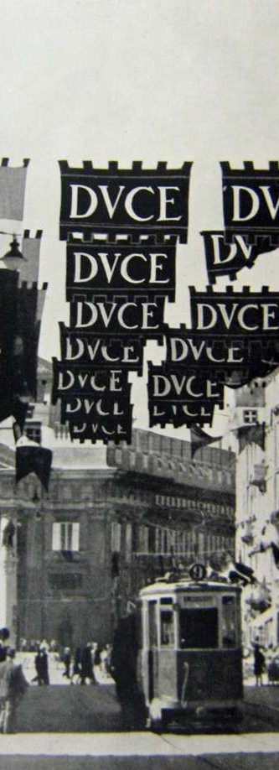
The Antipodean East European Study Group will host a talk:

René Moehrle
Trier University (Germany)

The ambivalence of Trieste

between multi-ethnicity and radical fascism

Abstract:
Mussolini visited Trieste three times before rising to power, studying the success of the local movement. Trieste then hosted the third largest Jewish Community in Italy and important local fascists were Jews. Anti-Semitic measures in Trieste increased since the early 1930s. In 1938, Mussolini visited Trieste to declare Jews enemies of Italian fascism in his only public speech on this topic. The German occupation of Italy in 1943 turned Trieste into the capital of the Adriatic Coastland, a special military operation zone governed by SS generals Friedrich Rainer and Odilo Globocnik. Globocnik constructed the only concentration camp south of the Alps with an incinerator.

12:00 noon on 7 February 2019
Wood Seminar Room (OK 406)
Victoria University
(Kelburn Campus)

This talk is free and
open to the public!

