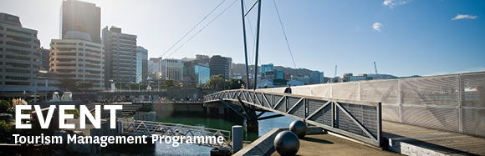
The Tourism Management Group, part of the School of Management, Victoria Business School,
invites you to attend the following seminar:
Developing and implementing the tourism insight framework
Steve Riley
Insight Specialist, Tourism Industry Aotearoa (TIA)

Monday 28th May

12.30 – 1.30pm

Room: MZ 05, Mezzanine Floor, Rutherford House
Pipitea Campus, Wellington

A Tourism Insight Framework to lead and manage the insight available to New Zealand tourism operators and support sustainable growth of the industry was launched by TIA on 13 November 2017.

Steve presents the framework and will elaborate on its aims to drive changes so that tourism businesses and stakeholders have the quality knowledge needed to make better informed decisions and achieve better outcomes.

The industry-led framework has five inter-related elements:

• leadership
• sustainable funding
• quality inputs
• technology
• enabling better decisions

Under each element, the Tourism Insight Framework sets out a series of actions for both the private sector and government.

About the presenter:
Steve enjoys making insight more relevant to the tourism industry by leading projects and initiatives that improve the insight available. Steve was a key project team member in the development of Tourism 2025 and continues to be a strong advocate of the growth framework. More recently Steve has led the industry in the development of our new insight framework.
ALL WELCOME

Any queries please email: tourism@vuw.ac.nz

