“The Politics of Categorizing Linguistic Varieties”
Conference: 13-14 July 2019
With growing scholarly interest in the process of categorization, it is timely to situate linguistic categorization within the broader history of ideas. This conference invites case studies in the politics of linguistic classification that place linguistic debates within the broader context of political struggles. Selective reading of linguistic evidence can justify fanciful theories: what theories have caught the fancy of scholars? Since the politics of linguistic categorization has many dimensions, its study can be pursued on several levels.
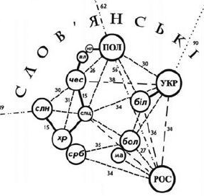
First, heated debate has often taken place as to how a given variety relates to others: the politics of cladistics and/or language trees is often hotly contested. Sumerian, for example, has inspired numerous claims, many of them outlandish, regarding its relationship to other languages; some apparently derive from the desire to claim a connection with the people who first invented literacy. During the nineteenth century, scholars debated whether Hungarian was closer to Turkish or Finnish, with many Hungarian scholars preferring to imagine their distant linguistic relatives as steppe-dwelling conquerors on horseback, rather than forest-dwelling hunter-gatherers. Claims to linguistic relationship are often taken to imply claims to kinship, and thus influence claims to indigeneity or distinctness.
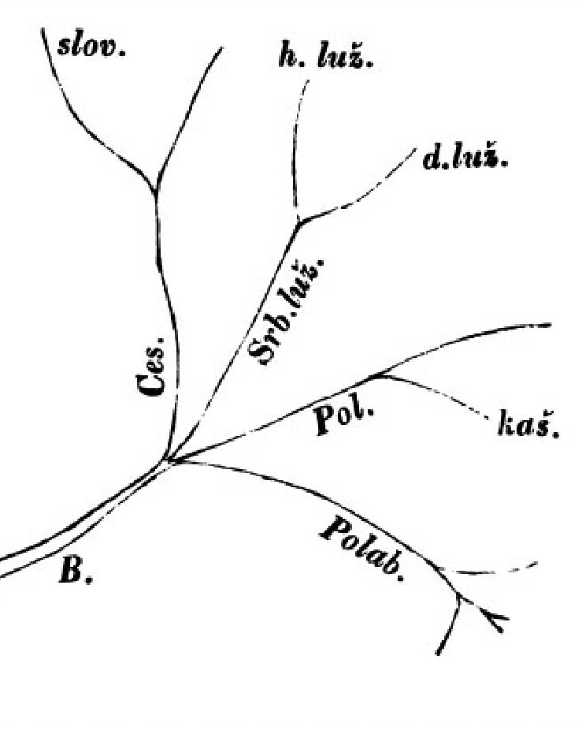
A second type of debate has centred on the status of a given variety within a language family. The quintessential debate of this type is the ‘language vs. dialect’ controversy, where one group argues for the distinct languagehood of a variety, while another denies it: the first Czechoslovak Republic insisted, for example, that Slovak, now recognized as a separate language, was a dialect of a ‘Czechoslovak language’, and many scholars agreed. More exotic debates exist: during the heyday of Panslavism, scholars debated whether Slovak was a ‘dialect’ of Slavic, or a ‘sub-dialect’ of the Czech dialect of the ‘Slavic language’. Such debates often serve as proxies for debates about official recognition: many states mandate certain rights and resources to minority communities with distinct ‘languages’; few states assign the same rights and resources to minority ‘dialects’, ‘idioms’, ‘accents’, and so forth. Efforts to Romanize Chinese, Soviet language policy in Turkic central Asia, and missionary Bantu linguistics all offer particularly rich fields for examining the bestowal or withholding of prestigious linguistic status.
Finally, the debate may revolve around the applicability of descriptive categories. While some linguists once emphasized the Dutch origins of Afrikaans, in order to emphasize its European origins, recent scholars have preferred to emphasize its creole aspects, in order to mirror the diversity of post-Apartheid South Africa. We particularly invite investigations of political claims to linguistic categories we have not anticipated. Is there, for example, a politics of tonal language pride or agglutinative language chauvinism?
The conference will take place at the Kelburn Campus of Victoria University in Wellington, New Zealand on 13 and 14 July 2019. We regret we have no funds to cover travel costs.

Interested parties should send a single paragraph abstract of no more than 100 words to alexander.maxwell@vuw.ac.nz.

