Balkan Urban Experiences

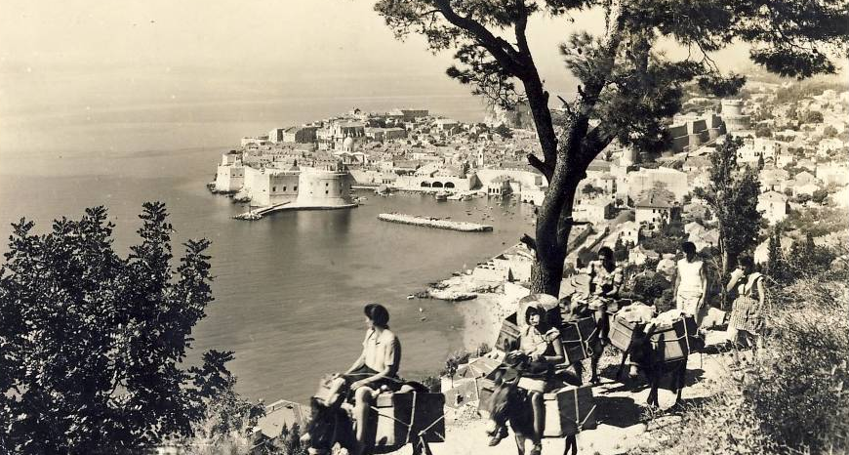

Though frequently neglected in European studies, the Balkans, and South-Eastern Europe generally, remains a region of great significance to European history and society. This interdisciplinary workshop seeks to examine urban experiences in this region. How has the political, economic, cultural, national, and religious life of the Balkans been affected by urban environments? Alternatively, how have Balkan cities been shaped by the unique experiences of its peoples?

The event will take place 18 August 2018 at the Kelburn Campus of Victoria University, Wellington, New Zealand, starting at 1:00 pm. The event is free and open to the public.

1:00 pm Marija Benić Penava (University of Dubrovnik)
“The Economic Development of Dubrovnik and Vukovar in the 1930s”

Based on a comparison of two cities at separate ends of Croatia, the talk highlights the impact of tourism and production of footwear in the Kingdom of Yugoslavia. Dubrovnik became a recognisable foreign tourist destination in 1930s, a time when congress, health and cultural tourism were in a state of development. In Borovo near Vukovar, the shoe concern Bata opened the largest shoe factory in Yugoslavia, gradually changing the rural suburb area of Vukovar into a modern industrial settlement. The appearance and everyday life of the both cities gained the features that were in line with the dominant activities taking place in them.

1:45 am Alexander Maxwell (Victoria University of Wellington)
“Budapest and Thessaloniki as Slavic Cities”

This paper examines how a national movement can arise in a city that (1) was dominated by another ethnic group and (2) lay outside the national ethnoterritory. This paper specifically examines Budapest and Thessaloniki as centres for Slavic activism. The role these cities played in Slovak and Macedonian nationalism suggests that urban institutions were more important to emerging national movements than a demographically national environment. The non-Slavic surroundings apparently encouraged Slavic patriots to seek reconciliation with other national groups.

2:30 pm Sacha Davis (University of Newcastle)
“The head and the heart of our national life”: Transylvanian Saxon exclusiveness in Hermannstadt (Sibiu) before the Second World War.

Although the Transylvanian town of Hermannstadt (Sibiu) was as multiethnic, multilingual and multi-religious as most Balkan cities before the Second World War, Transylvanian Saxon nationalists asserted Hermannstadt’s specifically “Saxon” character, claiming for themselves a civilised urbanity, while castigating non-Saxon residents as primitive interlopers. Saxon nationalists attempted to preserve their dominance in the face of Romanian rule by maintaining control over key urban institutions, restricting commerce with non-Saxons, and attempting to exclude non-Saxons from owning property in the Altstadt. Simultaneously, they reached out to the formerly marginalised Saxon proletariat in the outer suburbs. These efforts failed to reverse the lived experience of a multiethnic Balkan urban centre in which non-Saxons increasingly occupied positions of social, political and economic importance.

