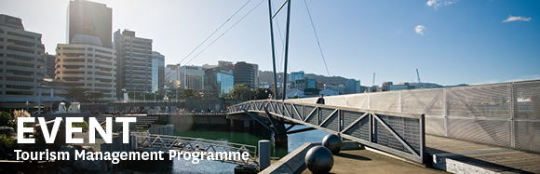

|  |  |  |  |  |  |  |  |  |  |  |
| --- | --- | --- | --- | --- | --- | --- | --- | --- | --- | --- |
| |  |  |  |  |  |  |  |  |  |  | | --- | --- | --- | --- | --- | --- | --- | --- | --- | --- | | |  | | --- | | The Tourism Management Group, part of the School of Management, Victoria Business School,  invites you to attend the following seminar: | |  | | **Freedom Camping: the freedom campers and resident perspectives** | | | **Dr Christian Schott** Victoria University of Wellington  **Monday 12th March**  **12.30 – 1.30pm**  **Room 205, Level 2, Rutherford House**  **Pipitea Campus, Wellington**  The practice of freedom camping, which can broadly be described as overnighting in public places without having to pay, has seen a notable increase in popularity in New Zealand in recent years. At the same time media interest in freedom camping, particularly reporting on tensions between freedom campers and residents, has also increased significantly to propel the topic to not only a regular feature in the media but also to an election issue in New Zealand’s 2017 General Election.  This seminar seeks to inform the public debate about Freedom Camping and its perceived impacts by providing research insights that illuminate resident and freedom camper perspectives on this under-researched issue. The findings are based on an intercept researcher-administered questionnaire survey in Wellington that formed part of a final year tourism research course. The response patterns by freedom campers were observed to be inconsistent when addressing the key concepts of ‘freedom’ and ‘free’. However, promising consensus was observed between the two groups with regard to the management of freedom camping despite the media narrative presenting residents and freedom campers as taking strongly opposing positions on the freedom camping debate.  **About the presenter**:  Dr Christian Schott is Senior Lecturer in Tourism Management at Victoria Business School and the coordinator of the UN Principles of Responsible Management Education at VBS. His research interests include the impacts of tourism, climate change and education for sustainability. This area of work has seen him engaged in research projects in the Sub-Antarctic, the Pacific and New Zealand. He additionally studies the travel motivations, travel experiences and self-development outcomes of young travellers. In this context Christian was awarded a three-month DAAD Scholarship at Technische Universitaet Berlin (Germany) in 2014.  ALL WELCOME | | |  | | |  |   Any queries please email: [tourism@vuw.ac.nz](mailto:tourism@vuw.ac.nz) |